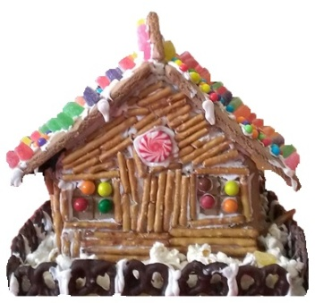

11th Annual Gingerbread House Competition
December 2nd, 1:00PM to 3:00PM

Theme: “Lenox Through the Years”

Contact Name: _________________________________________________________________

Name of Group/Organization (if applies): ___________________________________________

Title of Gingerbread House: _______________________________________________________

Number of Participants: ______

Category (please circle one):

Professional Adult Amateur Children

Address: _____________________________________________________________________

Telephone Number: ____________________________________________________________

Email Address: _______________________________________________________________

I regret that I cannot participate this year, but please accept the enclosed donation of ____________ to The Lenox Library to help support its programs and services.

Please return forms to the library by Saturday, November 25th.
All houses must be delivered to the library’s Welles Gallery from 9-11:00 a.m. on Sat., Dec 2nd.

All parts of the house except for the base and lighting should be edible. Please take into consideration that auction winners will be taking your house home, so make it no larger than 3’ x 3’. Bigger is not always better.

This family event should be fun for all, and we appreciate your holiday spirit in this competition!

